Writing
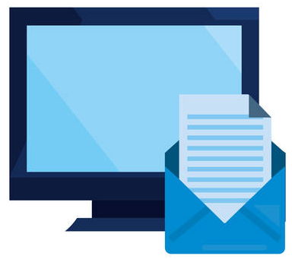
Professional
Emails:
Engaging with professional emails and exploring them in more detail
Intro

Emails: Engage
We will study about professional emails in this part of the course. Discuss the questions below with a classmate.
- How are social media posts and emails similar? Different?
- Identify 3 advantages of emails over social media posts:
- _________________________________________________________
- _________________________________________________________
- _________________________________________________________
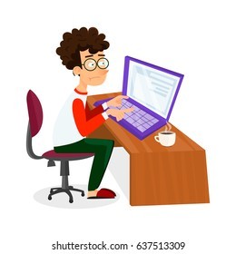
- How often do you write emails?
- Give 3 different examples of why you write emails, identifying the:
  - Audience
  - Purpose

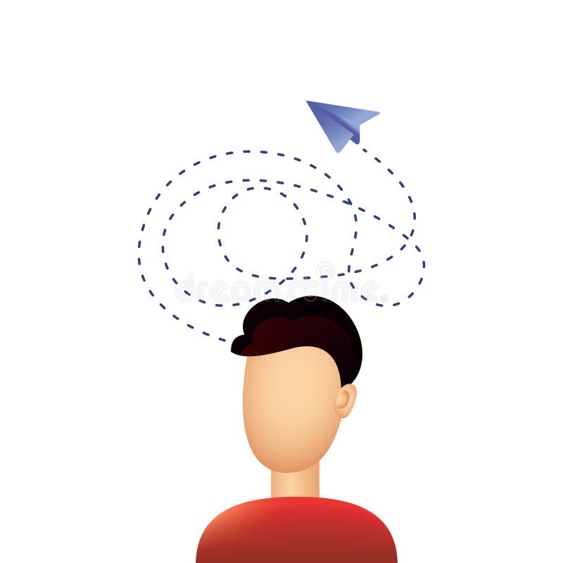
Email Quiz
How much do you really know about emails? Test yourself…
- Ray Tomlinson sent the first email in _____.
- 1917 b) 1971 c) 2017

- His first message was ‘QWERTYUIOP’, which came from his _____.
- home address b) bank account c) keyboard

- Microsoft made MSMail in 1988, which has now become _____.
- Outlook b) Gmail c) Hotmail

- Currently, the most popular email app is _____.
- Gmail b) Outlook c) Yahoo

- Nowadays, more than _____ people use email.
- 430,000 b) 4,300,000 c) 4,300,000,000

- The average businessperson in the US receives _____ emails per day!
- 21 b) 121 c) 1,221

- Be careful! There are about _____ spam messages sent every day.
- 340,000 b) 3,400,000 c) 3,400,000,000
Email Structure
Can you identify the 6 main features of a professional email?

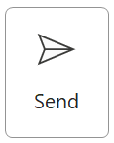 | 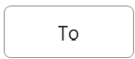 | r_______________
 | 
 | s______

g______________
b______________

c______________

s______________
Emails & Professionalism
Compare the two emails. Which one is more professional? Give 5 reasons why.
B
A
 |  | jsmith@ABCU.com
 | 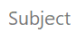 | Help me now!!!
Hey, Dr. S!!! How ya’ doin’??? Fyi, I’m gonna talk about yer class, ok!?
My head is ALL messed up!!! Like, really, I’ve got ZERO idea what you are blabbing on about lol. This stuff is drivin’ me CRAZY. Haha…Whenn ru gonna help me? I gotta PASSSSSS the TEST, you know???
Cu later alligator! Fatum
jsmith@ABCU.com
Request for grammar support
Dear Dr. Smith,
I hope you are doing well. I am writing about my study in your LSC 1103 English class.
I do not understand the new grammar in week 7. Although I reviewed it at home and did the online practice, I am still confused.
Can I meet you for extra support this week? I want to be ready for the midterm test.
Kind regards,
Fatima Ali Al Badr
H00123456
CRN 54321
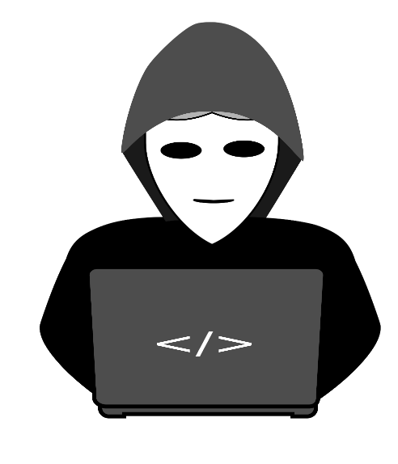
Emails & Passwords
Hackers are very good at discovering passwords.
Here is a technique to make a very personal password that should be easy to remember and highly secure:
- Think of a true sentence about yourself. Write it down.
- Make sure it has some proper nouns, numbers and a symbol.
- Take the first letter of each word, the numbers and the symbol.
- Put them together to make your password.
For example, if your sentence is: I started college in September 2023!
Your password would be: IsciS2023!
Or: My family and I went to Thailand 3 times. = Mf&IwtT3t
This might not be the best way for everyone, but it might work for you. Give it a try with your college email but keep your sentence in a safe place.

Quiz Source
https://contentsnare.com/email-facts/

Barry McDonald
Professional Written Communication / Emails 0 / Introduction
March 2025

